Applications Worksheet
Define a variable and write an equation for each situation. Then solve.
1. Suppose you are helping to prepare a large meal. You can peel 2 carrots per minute. You need 60 peeled carrots. How long will it take you to finish if you have already peeled 18 carrots?
2. One health insurance policy pays people for claims by multiplying the claim amount by 0.8 and then subtracting $500. Find the claim amount for an insurance payment of $4650.
3. Last season. Everett scored 48 points. This is 6 less than twice the number of points Max scored. How many points did Max score?
4. A cable TV company charges $24.95 a month for basic cable service and $6.95 a month for each additional premium channel. If Sami’s monthly bill is $45.80, how many premium channels is he receiving?
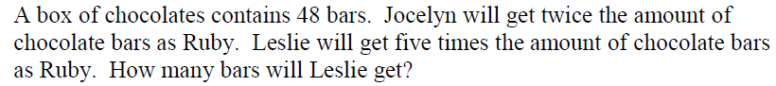
5.

6. You are fencing a rectangular puppy kennel with 25 ft of fence. The side of the kennel against your house does not need a fence. This side is 9 ft long. Find the dimensions of the kennel.
7. Canoe Rental: $5 per hour and $2 for life Jacket.
John and two friends rent a canoe at a park. Each person must rent a life jacket. If the bill for the rental of the canoe and life jackets is $41, for how many hours did they rent the canoe?
8. The Rodriquez family rented a moving truck for $49.95 plus $.30 per mile. Before returning the truck, they filled the tank with gasoline, which cost $18.32. The total cost was $95.87. Find the number of miles the truck was driven.
9. Lumanauw’s Truck rental charges $54 a day plus 9 cents per mile. Jones’ Truck rental charges $38 a day plus 13 cents per mile. For how many miles will the cost of renting a truck for one day at Lumanauw equal the cost at Jones’?

