Name________________________________________
Geometry
Chapter 8 Test Review

#1 and 2, find the sum of the measures of the interior angles of the indicated convex polygon.
1. Hexagon | 2. 20-gon
#3 and 4, the sum of the measures of the interior angles of a convex polygon is given. Classify the polygon by the number of sides.
3. 1800⁰ | 4. 2520⁰
#5 and 6, find the value of x. Show your work!!
5.  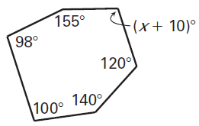 | 6.  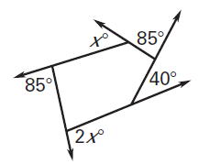
#7 and 8, find the value of x in the parallelogram. Show your work!!
7.  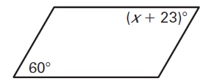 | 8.
#9 and 10, find the value of x. Show your work!!
9.  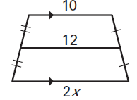 | 10.  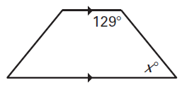
#11 – 14, give the most specific name for the quadrilateral.
11.  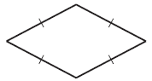 | 12.  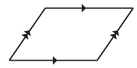
13.  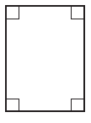 | 14.  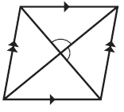
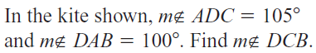
15.
