Geometry
Mr. Lumanauw
Circle

Circle –

Radius –

Chord –

Diameter –

Secant –

Tangent –

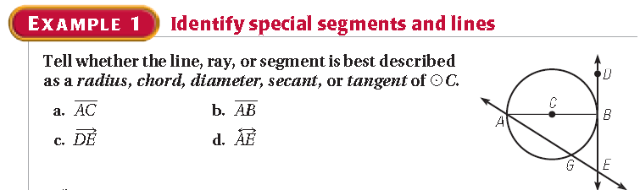

Solution:

a.

b.

c.

d.

