Geometry
Mr. Lumanauw
Circumference and Arc Length of a circle

I. Circumference.

- The circumference of a circle is _____________________________________________________

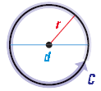
$C= πd$

Or

$$C=2πr$$

- Example 1:
Find the indicated Measure

a. Circumference of a circle with radius 9 centimeters
b. Radius of a circle with circumference 26 meters.

Solution:
a. | b.

II. Arc Length

- Arc Length is ______________________________________________________________________

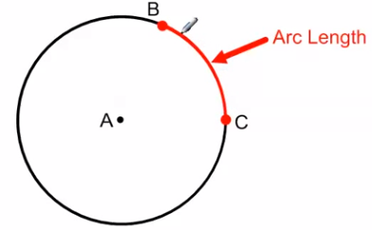

- Two kinds of arc length.
Degree  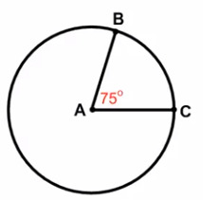  By Central Angle:  Central Angle = | Distance (inches, feet, centimeters, etc.)  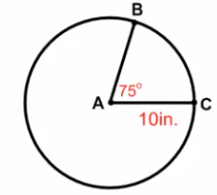  By Proportion:  =

Example 1:
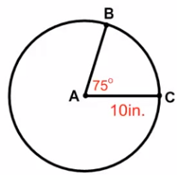

Example 2:
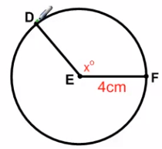

Example 3: $Find the radius of circle G, if the \hat{HJK }has an arc length of 27.5 ft$
