Name_______________________________________________ 11/5/13
Cross Sectional Area
Geometry.

1) Describe the cross sections (Parallel and Perpendicular) of each figure.
2) Find the Area of the cross section Parallel to the base
3) Find the Area of the cross section Perpendicular to the base

- Diameter = 10m  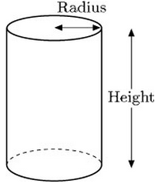 | 