Name: ________________________ G.GMD.4 Identifying Three-Dimensional Figures
by Rotating Two-Dimensional Figures

For questions 1-3 go the website http://www.shodor.org/interactivate/activities/3DTransmographer

Question 1: The Right Triangle
Create a Polygon with 3 vertices. Use the following points as the vertices.
1: (9, 0)
2: (0, 0)
3: (0, 10)
Click the “Graph” button to graph the polygon.

A. Predict and sketch what three-dimensional shape will be formed when you rotate the right triangle around the y-axis.

B. Under the “Revolve” box, click the last button that says, “across x = 0.” Then, click the “Revolve” button. What three-dimensional figure is formed by rotating the right triangle around the y-axis? Was your prediction accurate? Explain your reasoning and sketch a picture.

C. Under the “Revolve” box, click the first button that says, “across y = 0.” Then, click the “revolve” button. What three-dimensional figure is formed by rotating the right triangle around the x-axis? Sketch a picture.

Question 2: The Rectangle
Create a Polygon with 4 vertices. Use the following points as the vertices.
1: (10, 0)
2: (10, 6)
3: (0, 6)
4: (0, 0)
Click the “Graph” button to graph the polygon.

A. Predict and sketch what three-dimensional shape will be formed when you rotate the rectangle around the y-axis.

B. Under the “Revolve” box, click the last button that says, “across x = 0.” Then, click “Revolve.” What three-dimensional figure is formed by rotating the rectangle around the y-axis? Was your prediction accurate? Explain your reasoning and sketch a picture.

C. Under the “Revolve” box, click the first button that says, “across y = 0.” Then, click “Revolve.” What three-dimensional figure is formed by rotating the rectangle around the x-axis? Sketch a picture.

Question 3: The Trapezoid
Create a Polygon with 4 vertices. Use the following points as the vertices.
1: (10, 0)
2: (4, 8)
3: (0, 8)
4: (0, 0)
Click the “Graph” button to graph the polygon.

A. Predict and sketch what three-dimensional shape will be formed when you rotate the trapezoid around the y-axis.

B. Under the “Revolve” box, click the last button that says, “across x = 0.” Then, click “revolve.” What three-dimensional figure is formed by rotating the trapezoid around the y-axis? Was your prediction accurate? Explain your reasoning and sketch a picture.

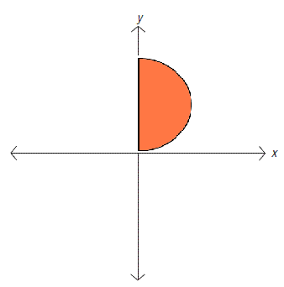
Question 4: The Semicircle
Given the semicircle to the right.

A. What three-dimensional figure is formed when the semicircle is rotated around the y-axis?

B. What three-dimensional figure is formed when the semicircle is rotated around the x-axis?

Question 5: Working Backwards
A. What two-dimensional figure is rotated around the x-axis to form a cone?

B. What two-dimensional figure is rotated around the y-axis to form a hemisphere?

Question 6: Summary
A. What two-dimensional figure would you rotate and around which axis to make an upside down cone? Identify the figure and sketch the picture.

B. Create a three-dimensional figure and describe what two-dimensional shape you rotated to form your figure. With a partner, switch three-dimensional figures. Determine what two-dimensional shape your partner used to create their figure.

