Name_____________________________________________ 10/15/13
Geometry. Law of Sines and Cosines
Use the Law of Sines for #1, 3, 5 Use the Law of Cosines for #2, 4, 6
1.  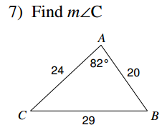 | 2.  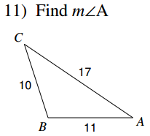
3. Solve the triangle. Round answers to nearest tenth.  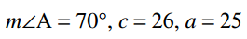 | 4.  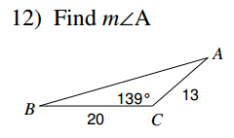
5. Solve the triangle. Round answers to nearest tenth.  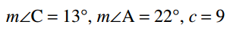 | 6.

