Practice
Using Intercepts

Name_________________________________________________________ Per ____ Date______

Identify the x intercept and y intercept of the line.
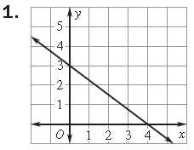  x-intercept: (4, 0)  y-intercept: (0, 3) | 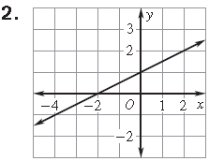 | 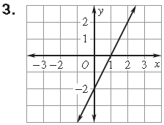
Find the x intercepts and y intercepts, then graph the equations.
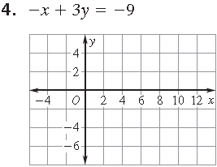 | 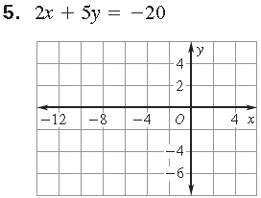 | 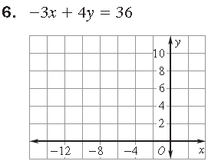
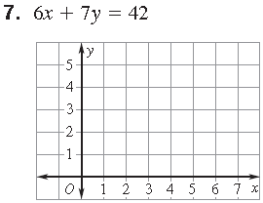 | 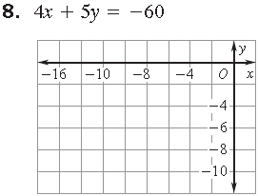 | 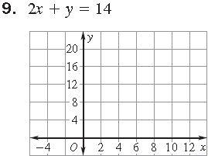
10. -2x + 7y = -14  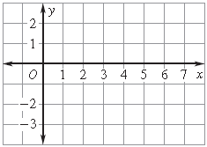 | 11. -3x + y = 9  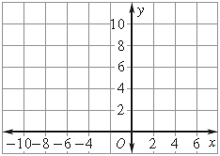 | 12. 3x + 4y = -24  