Task #1
Find the total number of running and passing plays for week 1 of the season. The Bobcats ran 100 plays and averaged 2 yards a run and 5 yards a pass for a total of 306 yards:
1. Write a system of equations to represent the offensive plays for three weeks ago where x is the number of running plays and y is the number of passing plays.

2. Estimate the number of running plays and passing plays using the graphing method for solving the system you created.
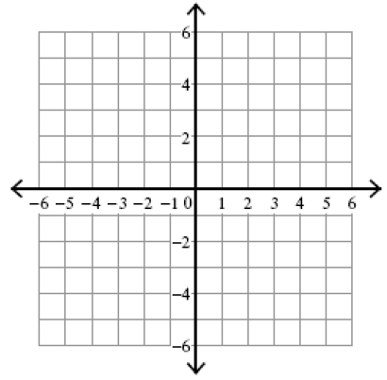
3. Write in at least three complete sentences, your answer in the context of the problem, explain how you used your graph to determine your solution, and why the solution is unique.

