Name_____________________________________________Geometry. Task #1
1. Below are some pictures of real objects. Also, there is a list of geometric names for shapes. Write, in the space below each object, the geometric shape that would be the best geometric model for that object. Every real object must be associated with only one geometric shape and each geometric shape may only be used once.
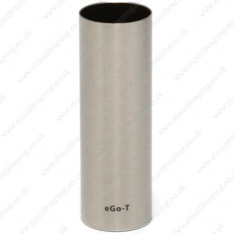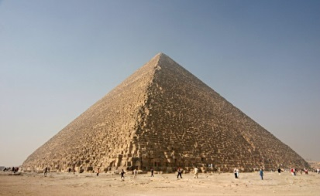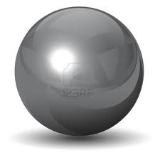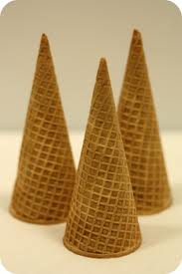

a)_____________ b) __________________ c) _______________ d)_______________
2. Identify the shape of the two-dimensional cross-section, parallel to the base, of each of the pictures above.
a)______________ b) __________________ c) ________________ d)_______________
3. Each of the three-dimensional objects have a “length”, “width”, and “height” associated with them. Afterall, that is what makes them three-dimensional objects. From part 2 above, you determined a two dimensional cross-section formed by a plane parallel to the base for each picture. The two-dimensional cross-sections have dimensions “length” and “width”. For each picture, describe how the two-dimensional cross-sections change, in terms of the dimensions, as the cross-section goes from the base of the object to the top of the object. For each description, you must use at least three complete senctences.
4. Suppose the cross-sections were not parallel to the base! Determine and describe in at least three complete sentences, the two dimensional objects formed under the following conditions:
a) Cross-sections of the cylinder formed by planes perpendicular to the base.
b) Cross-sections of the square pyramid formed by planes perpendicular to the base.
c) Cross-sections of the sphere formed by planes at an angle of 45 degrees to the base.
5. Each graph on the right below was generated by taking a graph on the left and revolving it. Identify which graph goes with each by matching the correct letter (ie. Graph z goes with graph y)

