Task #2
Find the total number of running and passing plays for week 2 of the season. The Bobcats ran 108 plays, but averaged 4 yards a pass and 4 yards a run for a total of 432 yards:
1. Write a system of equations to represent the offensive plays for two weeks ago where x is the number of running plays and y is the number of passing plays.

2. Use the graphing method to determine the number of running plays and passing plays for the system you created.
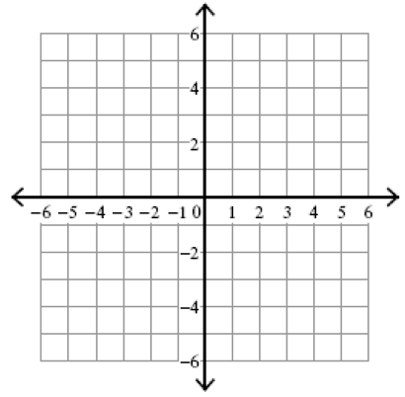
3. Find the number of running and passing plays using the substitution method.

4. Write a paragraph comparing and contrasting the graphing and substitution methods you used in solving the problem.

