Unit 5 Test Review
1. What is the x-intercept of the graph of $y=\frac{1}{2}x-3?$ | 2. What is the y-intercept of the graph of $-x+5y=-35?$
3. Write the equation of the line in slope intercept form. Given m = -4, (3, -5) | 4. Write the equation of the line in slope intercept form. Given $m=\frac{1}{3}, \left(3, 6\right)$
5. What is the domain of the relation  (7, 3) (6, 4) (4, 3) (3, 4) | 6. What is the slope of the line through the points (-3, 8) and (-6, 4) ?
7. What is the slope of the line through the points (3, 6) and (3, -9) | 8. Graph $y=-x+4$  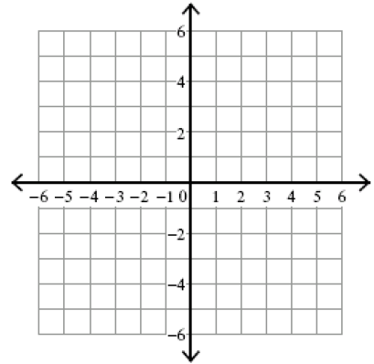
9. Graph $y=3x+6$ | 10. Graph $y=\frac{4}{3}x-8$
11. Graph $y-1=2(x-3)$ | 12. Graph $y=3 and x=4$ on the same graph. At what point do they intersect?
13. The table shows the number of miles a plane traveled while in flight. Use the information to find the approximate rate of change in miles per minute.  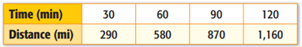 | 14. Find the rate of change of the data. Explain what the rate of change means.  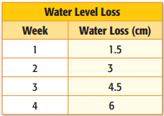
15. The graph represents the distance traveled while driving on a highway. Use the graph to find the rate of change in miles per hour.  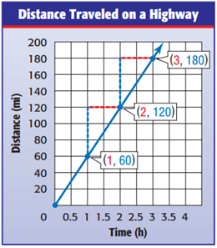 | 16. Make a table where the rate of change is  $5 for every gallon.  Gal. $

